# LAMP stack built with Docker Compose

This is a basic LAMP stack environment built using Docker Compose. It consists of the following:

* PHP 7.3 * Apache 2.4 * MySQL 5.7 * phpMyAdmin *elastic search7

## Starting Docker

sudo docker-compose up -d

## Shutting down Docker

sudo docker-compose down -v

## Connecting via SSH

sudo docker exec -it --user www-data webserver /bin/bash

## Flush Redis

Docker exec -it redis redis-cli FLUSHALL

## phpMyAdmin

phpMyAdmin is configured to run on port 9090. Use following default credentials.

http://domain.com:9090/

Database host : mysql

username: root

password: tiger

#stop PHP7.3 apache  
sudo service apache2 stop

## Redis

Redis. It runs on default port `6379`.

You can change the version of php, apache, mysql from docker hub.

**Creating New Vhost:**

1. **Open the following link**  ftp://192.168.1.7 download dockerfinal.zip
2. Extract to any location on you disk
3. Create a new folder with the name of your vhost your are setting docker for e.g (domain.com , replace domain with your own vhost name)
4. Extract /copy your data/magento setup files to domain.com
5. Change document root folder name in Docker-compose.yml, sample.env to domain.com , screen shots given below.

**docker-compose.yml**

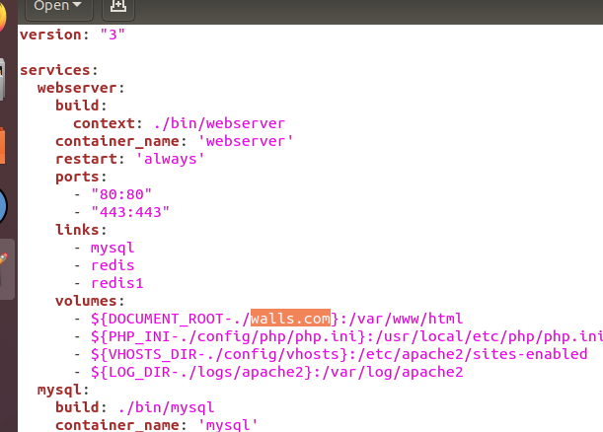

**Sample.env**

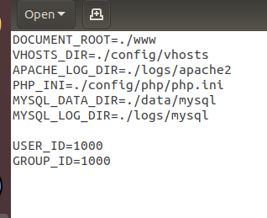

1. Change you ServerName to whatever name you have given to your root folder. I have mentioned as domain.com, screen shot given below.

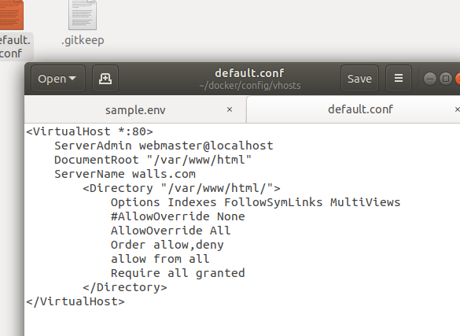

1. Open terminal and type “sudo nano /etc/hosts” , type in

127.0.0.1 domain.com

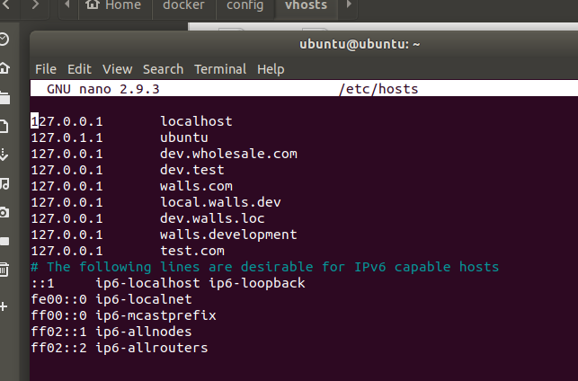

Crt+O and then enter will save this entry, Crt+x will exit from this.

1. Now open web page domain.com:9090 and make a new database for you site.
2. Open terminal and paste the below command, this will ssh the webserver container and you can run you PHP commands,

**sudo docker exec -it --user www-data webserver /bin/bash**

1. Domain.com/frconfig.php (if not working than create script)
2. Restore your database, open domain.com:9090 and change your urls in core_config_data table.

Then you can access your site domain.com

php bin/magento setup:upgrade &&

php bin/magento setup:di:compile &&

php bin/magento setup:static-content:deploy -f &&

php bin/magento c:f